PEER TO PEER PROGRAMING
NETWORKING PROJECT
P2P over LAN
BY:
1) KANIKA VATS (2K6/IT/932)
2) KARTIK RUSTAGI (2K6/IT/934)

Acknowledgement:

We are very thankful to Ms. Richa Gupta for her continuous support and excellent mentorship through out the process of completion of this project report.

---- Abstract----

As a part of our Term Project for the subject Computer Networks in 5th semester, Information Technology at Delhi College of Engineering, we have done a project on Peer to Peer networking system over LAN.
With this project we aim at establishing a P2P network over LAN such that it enables the easy transfer of files between various systems belonging to that particular LAN. This application has these two important features:-
- Dynamic addition of peers
- Facility to search for files among peers, without the knowledge of internal architecture
- Avoiding data conflict using the mechanism of semaphores
Thus unlike the various P2P applications that exist over internet for eg:- Limewire, Ares etc which are not “pure” p2p applications because they do have a central server to manage peers's status , we aim at establishing the a “pure” p2p file search/transfer application for LAN with the help of UDP(User Datagram Protocol). Our project has been implemented in Python language and was completed in three phases. These phases are as follows:-
- MESSAGE HANDLING
- FILE SEARCHING AND SHARING
- AVOIDING DATA CONFLICT

WHY PYTHON?

Python is an easy to learn, powerful programming language. It has efficient high-level
data structures and a simple but effective approach to object-oriented programming.
Python's elegant syntax and dynamic typing, together with its interpreted nature, make
it an ideal language for scripting and rapid application development in many areas on most platforms.
We have implemented our P2P protocol via Python because Python offers a simple interface (much simpler than the corresponding C implementation) to properly create and to do socket programming. The various added advantages are as follows:

- Python defines a socket () function returning a socket object. The socket has several methods, corresponding to their pairs from C sys/socket.h, like bind(), connect(),listen() or accept().

- Programmers accustomed with socket usage under C language will find very easy to translate their knowledge in the more-easy-to-use socket implementation under Python.

- Python eliminates the daunting task of filling structures like socket address with the help of provision of some functions like gethostbyname(), getprotobyname() and many more.

- HIGH LEVEL LANGUAGE: When you write programs in Python, you never need to bother about the low-level details such as managing the memory used by your program. For eg: there has been an extensive use of high level data structures like LISTS in our program, at each instance we need to update the list, delete its contents from variable position.If we were using C we would have to go through lot of programming statements but Python makes it very easy to carry out these operation by simply calling its embedded functions like ‘del’ or ‘append’.

- STRING()-Python includes a string module that helped us to carry out all sort of possible operations on strings by just calling appropriate String function.

- OS(),SYS()-The OS & SYS module helped us in implementing all the OS functions such as carrying out file transfer operation, creation of a directory, searching for a file in a particular directory.

WHAT IS PEER TO PEER PROGRAMMING??
P2P networks are typically used for connecting nodes via largely ad hoc connections. Such networks are useful for many purposes. Sharing content files (see file sharing) containing audio, video, data or anything in digital format is very common, and real-time data, such as telephony traffic, is also passed using P2P technology.
A pure P2P network does not have the notion of clients or servers but only equal peer nodes that simultaneously function as both "clients" and "servers" to the other nodes on the network. This model of network arrangement differs from the client-server model where communication is usually to and from a central server. A typical example of a file transfer that is not P2P is an FTP server where the client and server programs are quite distinct, the clients initiate the download/uploads, and the servers react to and satisfy these requests.
In 'pure' P2P networks:
- Peers act as equals, merging the roles of clients and server
- There is no central server managing the network
- There is no central router

Advantages of P2P networks
An important goal in P2P networks is that all clients provide resources, including bandwidth, storage space, and computing power. Thus, as nodes arrive and demand on the system increases, the total capacity of the system also increases. This is not true of a client-server architecture with a fixed set of servers, in which adding more clients could mean slower data transfer for all users.
The distributed nature of P2P networks also increases robustness in case of failures by replicating data over multiple peers, and -- in pure P2P systems -- by enabling peers to find the data without relying on a centralized index server. In the latter case, there is no single point of failure in the system.

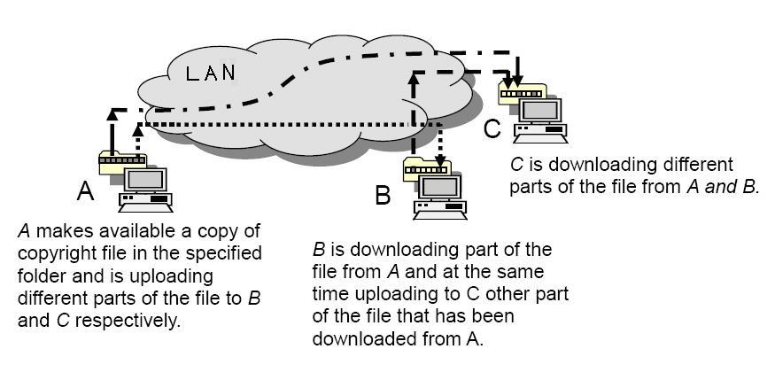
AS WE CAN SEE IN ABOVE PICTURE FILE SHARING IS TAKING PLACE WITH THE HELP OF P2P OVER LAN,


--------PROTOCOL DESIGN-------

1) MESSAGING SYSTEM:
Before beginning to write any code, we must first think about the design of the P2P protocol that we wish to implement. For a true, "pure" P2P network, every node (computer) will be running the exact same set of algorithms and code and there is no centralized server or any special node to keep status of peers, that is which peers are online and which are not, organized. Thus, we need to decide on the set of messages that the various nodes will exchange between each other and then focus on the behavior of a single node when it receives each type of message. And hence we designed our OWN PROTOCOL to handle all the needs of our application.
In the protocol that we designed and developed there are 7 types of messages:
- <pr1>: There are two types of messages that will be exchanged between the existing peers in order to declare their presence to others. Thus when a peer will start this application it will declare its presence by sending a message”<pr> I am online” to all the possible IP address range of the LAN .

- <pr2>:All the existing peers to which the above mentioned tag containing message is send will reply back to mark their presence by sending a message “<pr2> I am online too” .As the above mentioned messages will be exchanged between the existing peers, each peer will simultaneously update and maintain a list of the addresses of all the peers .

- <close>:Whenever a system running this application is going to go offline it sends a message containing I am going to be offline with this tag in it, telling all the peers about its future absence ,whenever this message is obtained by it peers they delete the corresponding address of the system from their peer list.
- <srr>: When ever a peer wants to search for a file among all the peers currently on the network, it sends a string with this tag along with the name of the file.
- <srs>:The peers accept message with tag <srr> and sends the result as '<srs>Yes' indicating success while searching for the file and '<srs>No' to indicate a negative result.
- <Begin>: When the peer that requested a file to be searched receives a positive reply in the form of '<srs>Yes', it asks for that peer to begin file transfer by sending '<Begin>'
- <End>:This tag is sent to indicate completion of a file transfer.
Other then these peers another important part of out protocol is a list Peers, which is used to maintain the status of peers in the network.

2) FILE SHARING AND SEARCHING:

To facilitate file search we have used the method of having a specific directory to store all the files that are shared among peers. All the files that are downloaded from the network are also saved in this directory. This directory is created by our script automatically by our script the first time it is run on a system at the location:-
- /home/user/p2p
This is according to the directory structure of linux kernel, linux being our test operating system.
When ever a file needs to be searched it is searched in this directory by using string matching.
To facilitate file transfer we have used the technique of standard input redirection. That is we have redirected the 'stdin' file at host peer to the file object that needs to be send.

3) AVOIDING DATA CONFLICT:

To avoid data conflict we have used a variable 'STATUS' so as to indicate whether a peer is busy in a file transfer or not. This variable is maintained locally by ever peer. A STATUS==1 indicate that indeed it is busy and all request to this peer are deferred and visa versa.

-------APPLICATION SCRIPT--------

-------SYSTEM TESTING-------

Due to the unavailability of multiple linux system on LAN we made a version of our script which runs on a single IP on a system,generally the 'localhost' that is on the IP 127.0.0.1 but on a specified port. Thus by running multiple instances script on different ports we were able to simulate our application completely and hence do comprehensive testing. The application worked as per our expectation.
-------FUTURE WORK-------

This application that we have made as a project for our Computer Networks subject perform all the basic tasks that are required to be done by such an application. But a lot of work can be done to further improve usage and performance of this application. Some of these are:-
- Having a threaded structure so as to handle multiple clients at a time.
- Having an interactive user interface so as to ease the usability of this application.
- To improve the search capabilities. Currently a search will match if the string matches EXACTLY. We aim to ease it by using various methods like Regular Expressions etc.

